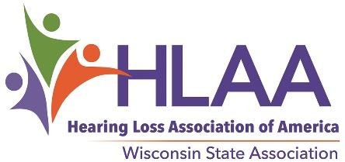

2022 Application/Nomination to the HLAA WI Board of Trustees
Name:________________________________ Title: ___________Phone #: ____________________
Address: _________________________________________________________________________
E-Mail Address: _______________ HLAA Membership# (On Magazine label): ____________________
I am: Hard of Hearing ___Hearing ___Parent of Child with Hearing Loss ___(age of child)___ Hearing healthcare professional ___Other: (Please explain) _________________________________
If you participate in a local HLAA Chapter, please tell us which one: __________________________
I understand that HLAA-WI Board Members must:
  - Be a national member of HLAA in good standing (Membership information at www.hearingloss.org)
  - Commit to a 3-year term on the HLAA-WI Board of Trustees
  - Commit to attending 2 meetings at a central location in Wisconsin each year; time, date & place determined by the board.
  - Commit to participate in 2 online meetings each year.
  - Commit to corresponding regularly by e-mail.
  - Be committed to the mission of HLAA: To open the world of communication to people with hearing loss through information, sharing, education, advocacy, and peer support.

Please use a separate sheet of paper to explain why you are interested in serving on the HLAA-@I Board. Include specific skill sets you have and tell us a little bit about your background.
I understand that HLAA-WI board members pay their own expenses to attend meetings. (Carpooling is encouraged and chapters are encouraged to offer support to their chapter members who serve on the HLAA-WI Board. HLAA-WI is a 501(c)3 nonprofit organization, therefore, mileage is deductible under IRS rules. Meetings generally do not require overnight travel.
__________________________________________ ______________________
Signature Date
You may apply for the board yourself or nominate someone who would serve well, with their permission. The current board offers opportunities in the following areas: PR/Marketing, Facilitating & Public Speaking, Parent Involvement, Walk4HearingCommittee, Fundraising, Advocacy, Website Management, Newsletter Editing and Board Leadership. All based on board need and your unique interests.

2022 Nominating Committee
Jack Spear jhspear@gmail.com
Pamela Martin mmmiracle4me@aol.com
Colleen Van Rooy cvanrooy@yahoo.com
Jerry Lapidakis
jlapidakis@gmail.com
The deadline for application/nomination is August 1, 2022. A ballot will be posted on the HLAAWI website home page no later than September 1, 2022. In addition, the ballot will be sent by email to all Wisconsin HLAA members. All active HLAA members in Wisconsin are eligible to vote. Members may also vote in person at the annual meeting on October 14.
Please fill out and return this application by mail or scanned e-mail to any of the members of the Nominating Committee, prior to August 1, 2022. A ballot will be posted on the HLAAWI website no later than September 10, 2022.
The elected board members will be introduced at the annual meeting in October.

